**Project ID - 421**

**Project Title - Book a doctor**

**Team Members:**

a) Anshita Banthia (20BCE10425)

b) Vedish Kabra (20BCE10407)

c) Nivedita Kokil (20BCE10341)

**1] INTRODUCTION**

The proposed project is an intelligent system for booking appointments with doctors, allowing patients and users to easily schedule appointments online. It is a web-based application that addresses the challenges of managing and scheduling appointments based on user preferences and demands. Manual allocation of appointments by the pharmacist or doctor can be a tedious task, considering the availability of the users. Therefore, this project offers an effective solution where users can view available time slots and select their preferred date and time. Already booked slots are marked in yellow and cannot be selected by others during that specified time. Additionally, users have the flexibility to cancel their bookings at any time.

The application has been designed to minimize errors during data entry and provides error messages for invalid inputs. Users do not require formal knowledge to use the system, making it user-friendly.

The Doctor Appointment System described above ensures an error-free, secure, reliable, and efficient management system. It allows users to focus on their other activities instead of record-keeping, ultimately leading to better resource utilization for the organization.

**2] LITERATURE SURVEY**

The literature survey of the project suggests an idea that is an intelligent system that makes it simple for patients and users to make online appointments with doctors. The difficulty of maintaining and scheduling appointments based on consumer requests and preferences is addressed by this web-based tool. Every single day we find numerous patients coming to the hospitals for either regular check-ups or for some serios ailments that need the supervision of the doctor. People run to the chemists or compounders to book themselves an appointment and it gets really hectic for them to reach to the doctor and book their appointments and reach for the appointment on time. They either have to wait in long queues for their turn to come, or sometimes are not even able to get the appointment on the required date and time. Also, considering the users' availability, the chemist or doctor may find it onerous to manually assign appointments.

Since consumers may browse available time slots and choose their favourite date and hour, this project provides a useful solution. This way it demolishes our second issue, of patients being sick and still needing to wait in long queues for their turns to arrive. In the project, yellow-marked slots are unavailable to other users during that time period since they have already been reserved. Additionally, individuals have the freedom to cancel their reservations whenever they choose. This makes it extremely easy and less time-consuming for everyone to get themselves checked-up by the doctor.

The application has been created to reduce the manual mistakes made when entering data and to display error messages for invalid inputs. This prevents the patients from committing the frauds against the doctors and pay them less, or not pay them at all, taking advantage of the doctors' negligence. Moreover, the system is user-friendly because it doesn't require formal training for users to operate it.

The management system is error-free, secure, dependable, and effective, by virtue of the doctor appointment system mentioned above. Therefore, the users are now able to concentrate on other tasks rather than record-keeping. The compounders in the hospitals too, need not maintain records, as the records are directly stores in the database of the application, which eventually results in improved resource allocation for the organisation.

**3]THEORITICAL ANALYSIS**

**3.1 Block Diagram:**

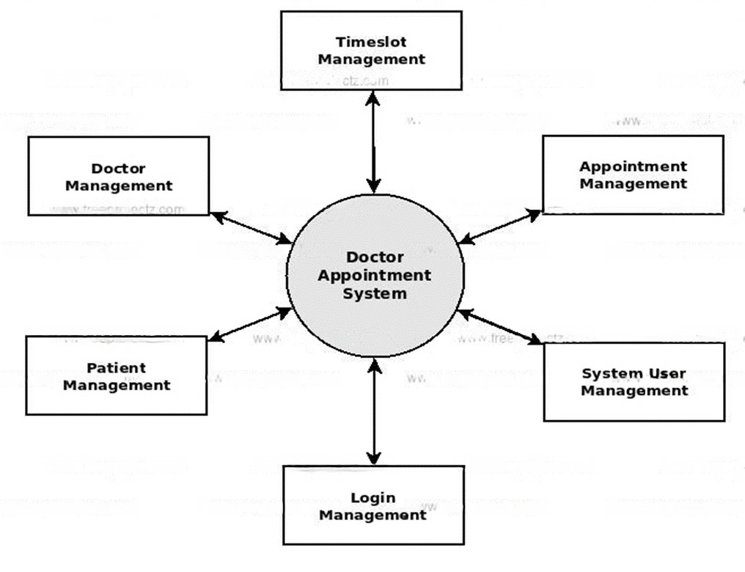

**3.2 Hardware/ Software Designing**

a) Tools/Libraries Used

1)Eclipse workbench

2)XAMPP

3)MySQL

c)Language Stack

1)Frontend

HTML

CSS

JavaScript

2)Backend

MySQL

**4]FLOW CHART**

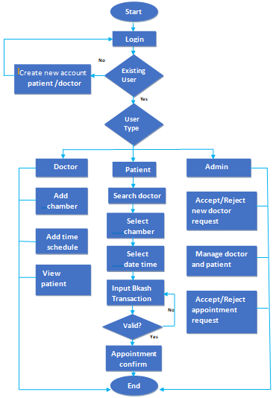

**4] RESULT (OUTPUT SCREENSHOTS)**

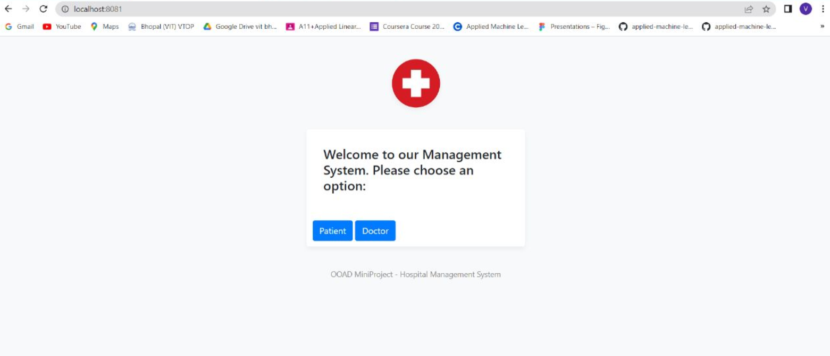

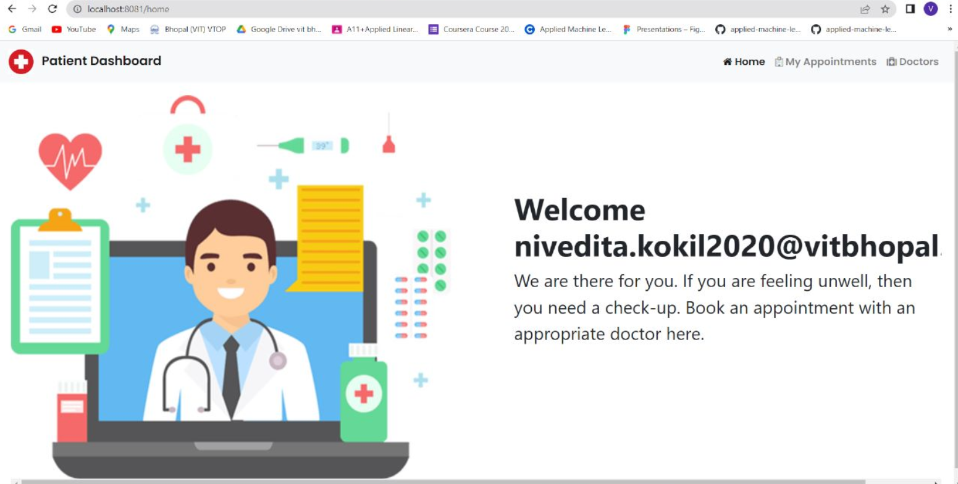

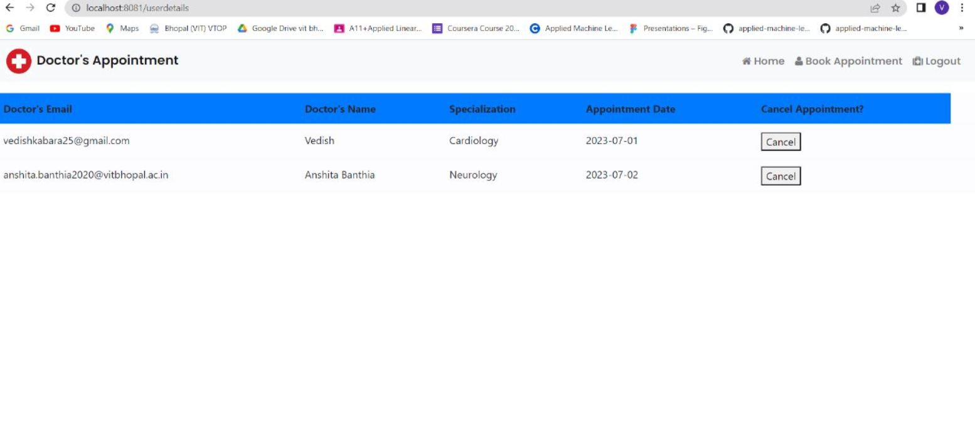

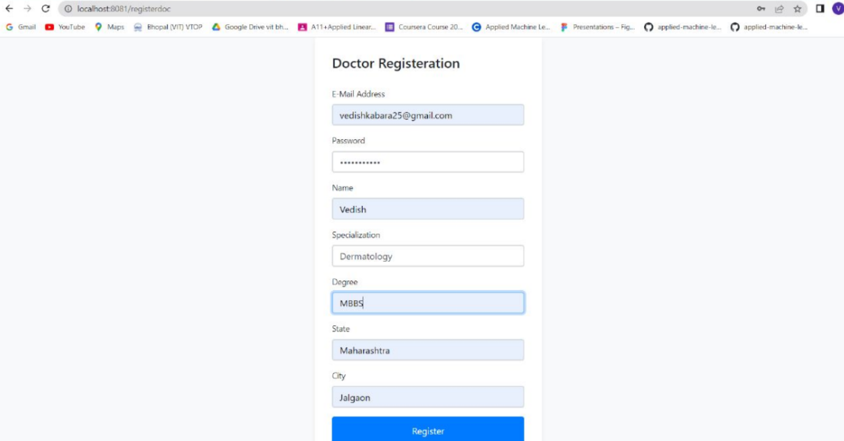

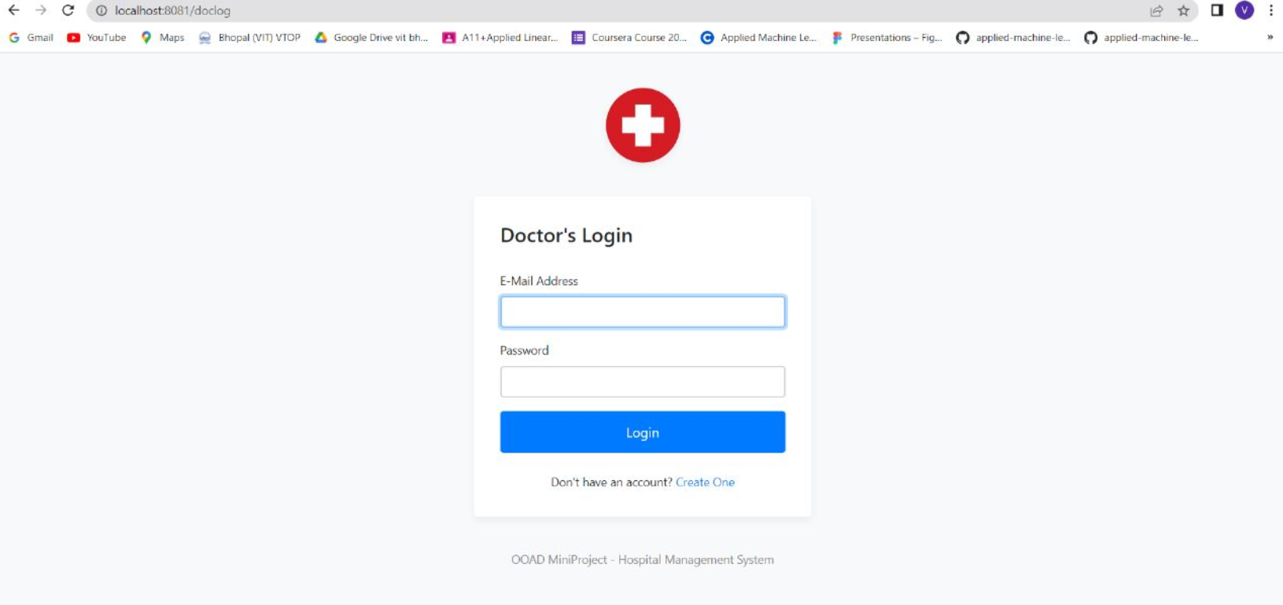

**6] APPLICATIONS**

* The proposed software product is the Appointment schedular System (HMS). The system will be used in any Hospital, Clinic, Dispensary or Pathology labs in any Hospital, Clinic, Dispensary or Pathology labs to get the information from the patients and then storing that data for future usage.
* The intentions of the system are to reduce over-time pay and increase the number of patients that can be treated accurately.
* This system includes registration of patients, storing their details into the system, and also booking their appointments with doctors.
* Our software would be used to give a unique id for every patient and stores the details of every patient and the staff automatically. User can search availability of a doctor and

the details of a patient using the id.

* The administrator or receptionist can add data into the database. The data can be

retrieved easily.

* The data are well protected for personal use and makes the data processing very fast. The interface is very user-friendly.

**7] CONCLUSION**

This initiative aims to computerise hospital operations. It much outperforms the manual system. The system's computerization has sped up the procedure. The front office management in the existing system is quite slow. The system underwent extensive testing with fictitious data and was proven to be very dependable. The software can handle all the needs of a typical hospital and can easily and effectively store patient information that is brought into the facility. It produces test results and offers the ability to look up patient information.

The software can handle all the needs of a typical hospital and can easily and effectively store patient information that is brought into the facility. It produces test results and offers the ability to look up patient information. Additionally, it offers a billing service based on the patient's condition, such as whether they are an indoor or outside patient. The system also offers the option of backup, depending on the situation.

**8] FUTURE SCOPE**

The proposed system is Appointment Scheduler System. We can enhance this system by including more facilities like pharmacy system for the stock details of medicines in the pharmacy. Providing such features enable the users to include more comments into the system.

By adding other features, such as a pharmacy system that tracks the inventory of medications in the pharmacy, we can improve this system. By offering these features, people can add more comments to the system.